Lateral Area

Definition
# Source: AI Source: Provided by: [Data Path: Persons Table -> ID Column: 1, Name_En Column: Motasem Essam] -> From: [ChatGPT] on [7/20/2026]
In geometry, lateral area is the total area of the lateral surfaces of a three-dimensional solid, excluding its base or bases.
In simple terms:
Lateral area measures the area of the side surfaces surrounding a solid, without counting the bases.
$$\boxed{\text{Lateral Area}=\text{Area of the Side Surfaces Only}}$$
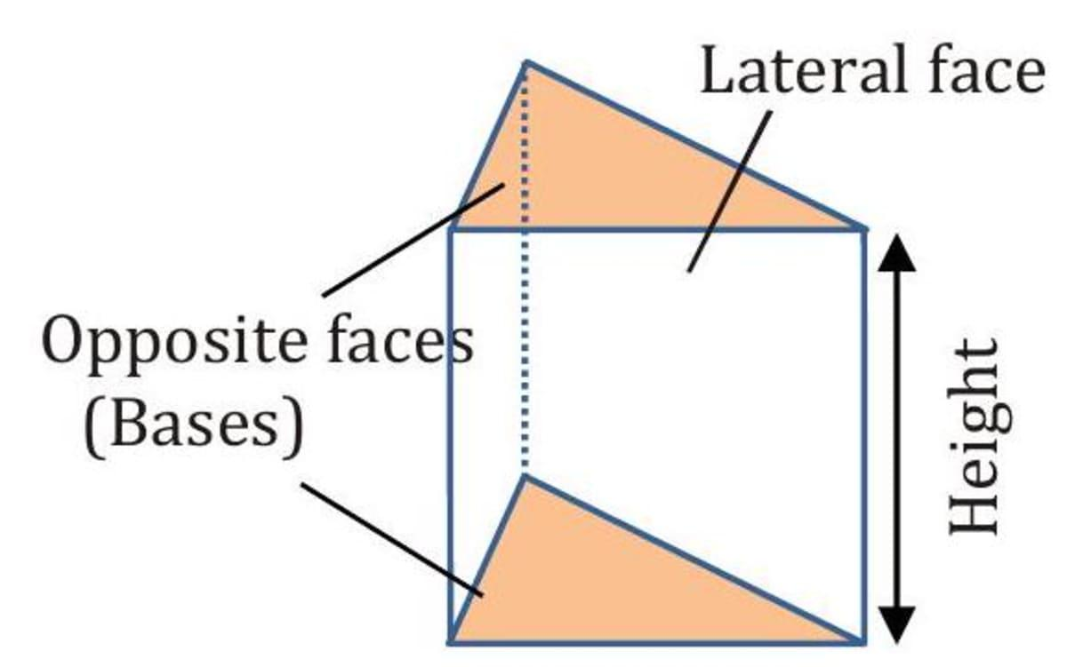
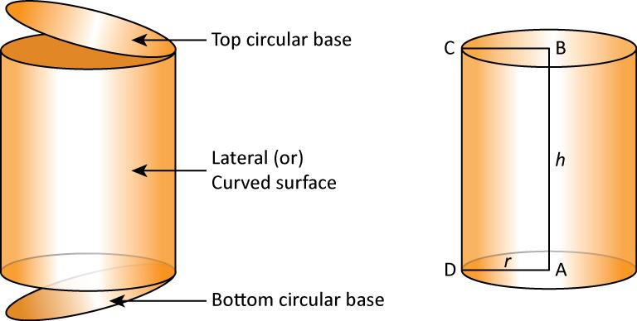
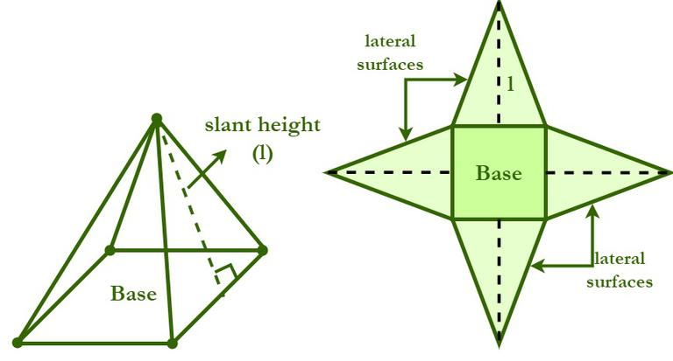
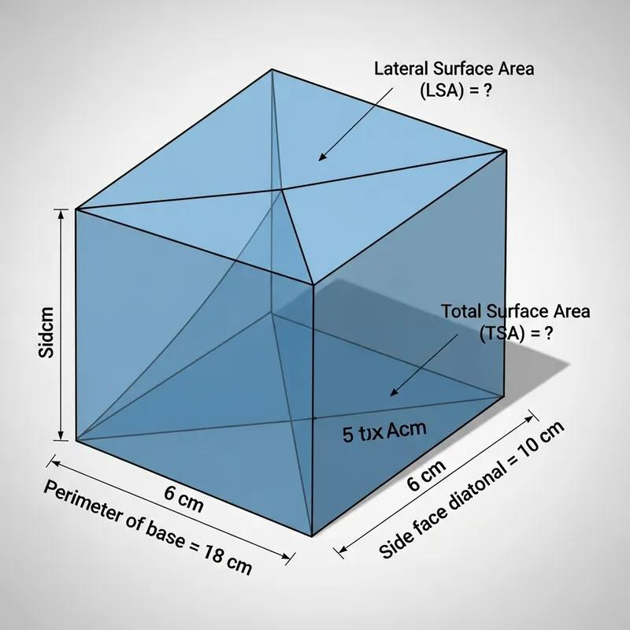
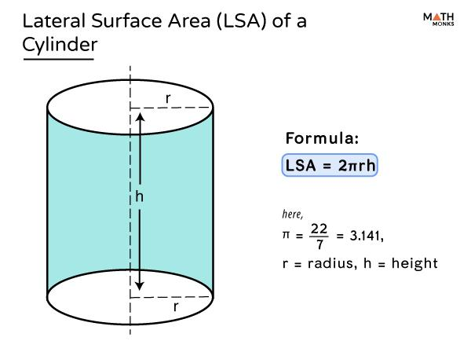
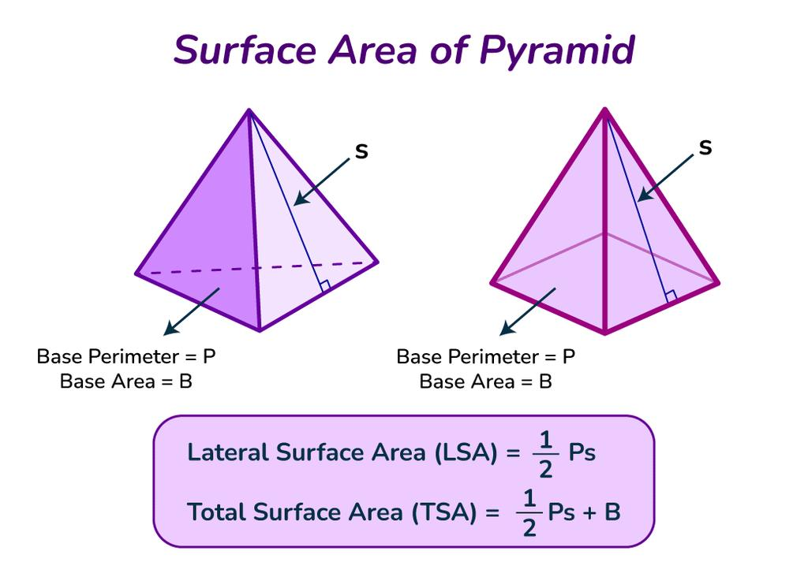
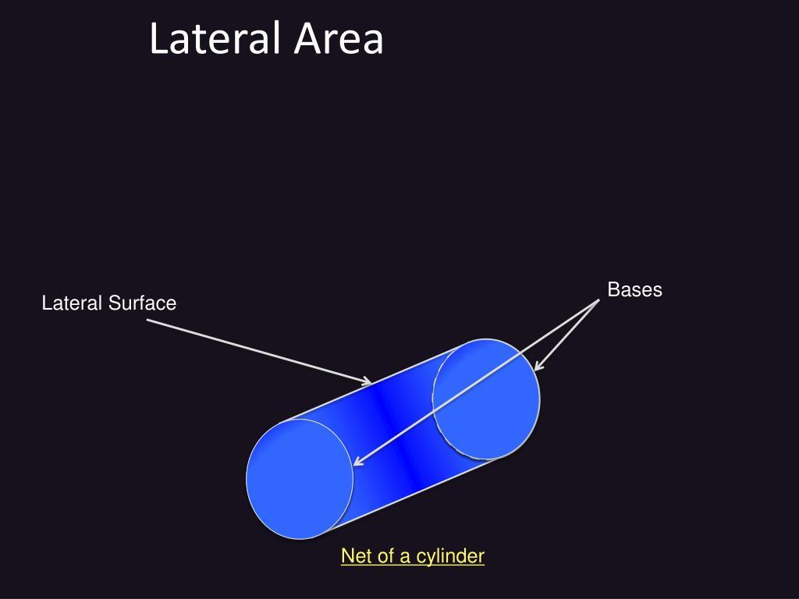
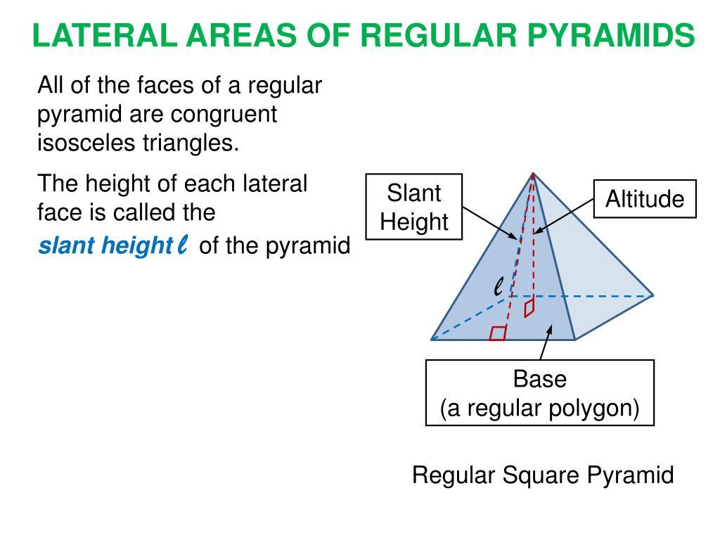

Characteristics
# Source: AI Source: Provided by: [Data Path: Persons Table -> ID Column: 1, Name_En Column: Motasem Essam] -> From: [ChatGPT] on [7/20/2026]
Lateral area:
- Applies primarily to three-dimensional solids.
- Measures the side surfaces of a solid.
- Excludes the base or bases.
- Is measured in square units.
- Is part of the total surface area.
$$\boxed{\left[LA\right]=L^{2}}$$
The relationship is:
$$\boxed{\text{Surface Area}=\text{Lateral Area}+\text{Area of Base(s)}}$$

Lateral Area vs. Surface Area
# Source: AI Source: Provided by: [Data Path: Persons Table -> ID Column: 1, Name_En Column: Motasem Essam] -> From: [ChatGPT] on [7/20/2026]
These concepts are closely related but are not the same.
Lateral Area
Only the side surfaces:
$$\boxed{LA=\text{Side Surface Area}}$$
Total Surface Area
All external surfaces:
$$\boxed{SA=LA+\text{Base Area(s)}}$$
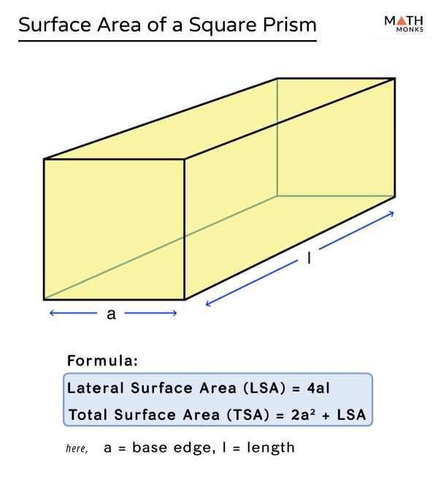
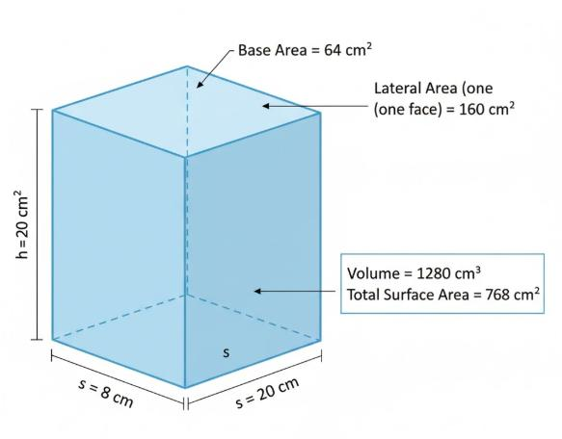
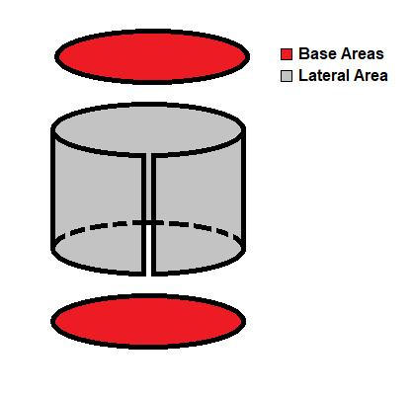
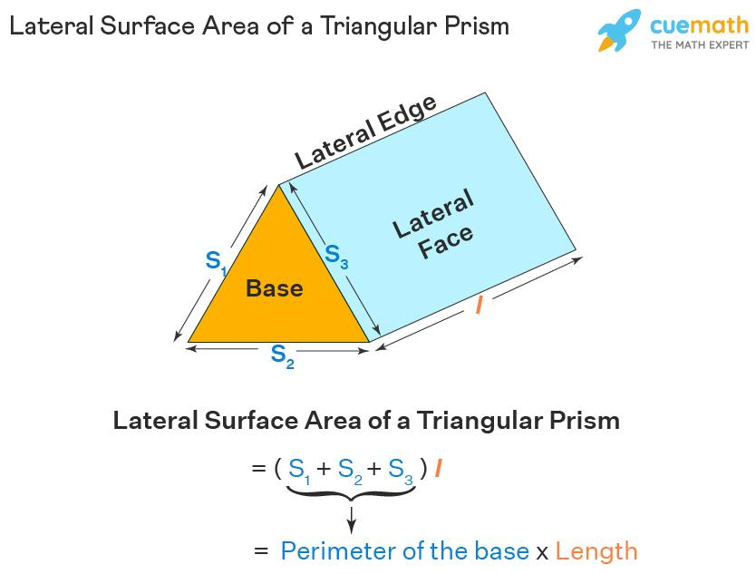
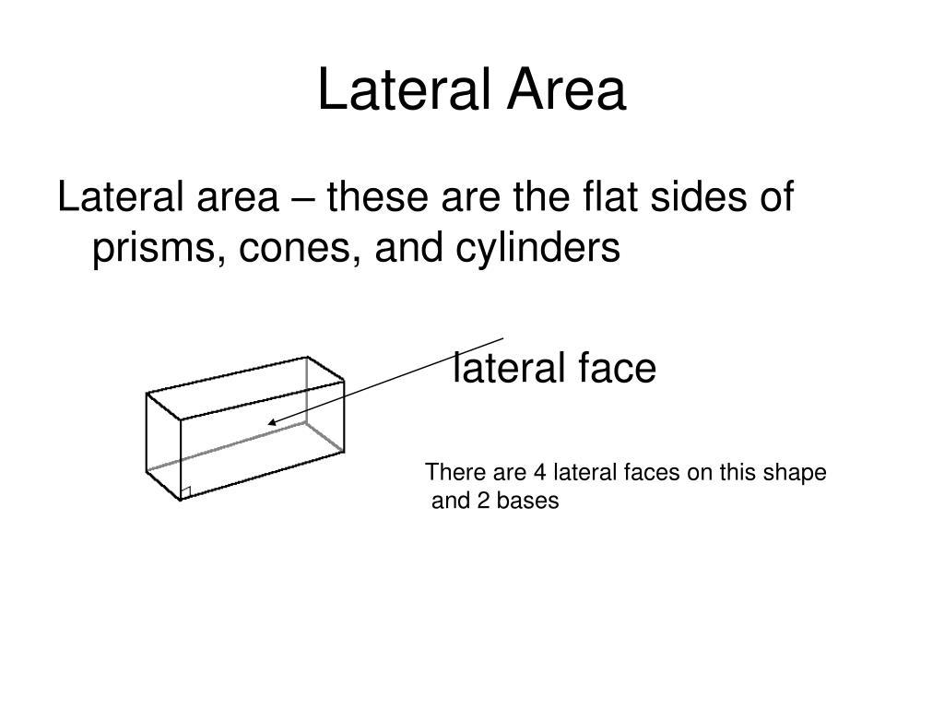

Lateral Area of a Prism
# Source: AI Source: Provided by: [Data Path: Persons Table -> ID Column: 1, Name_En Column: Motasem Essam] -> From: [ChatGPT] on [7/20/2026]
For a prism, the lateral surfaces are rectangles.
The general formula is:
$$\boxed{LA=Ph}$$
where:
- $P$ = perimeter of the base
- $h$ = perpendicular height of the prism
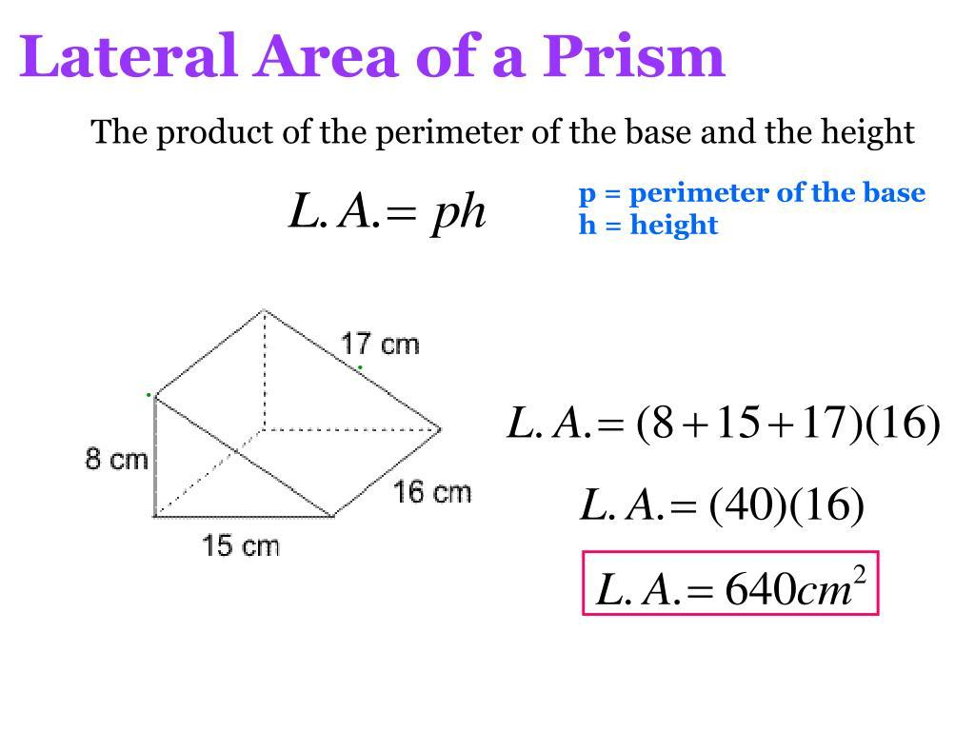
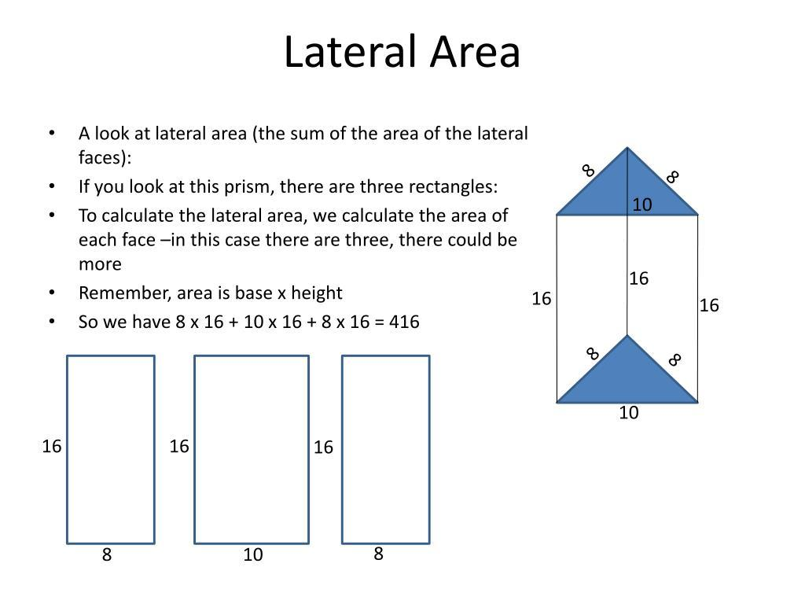
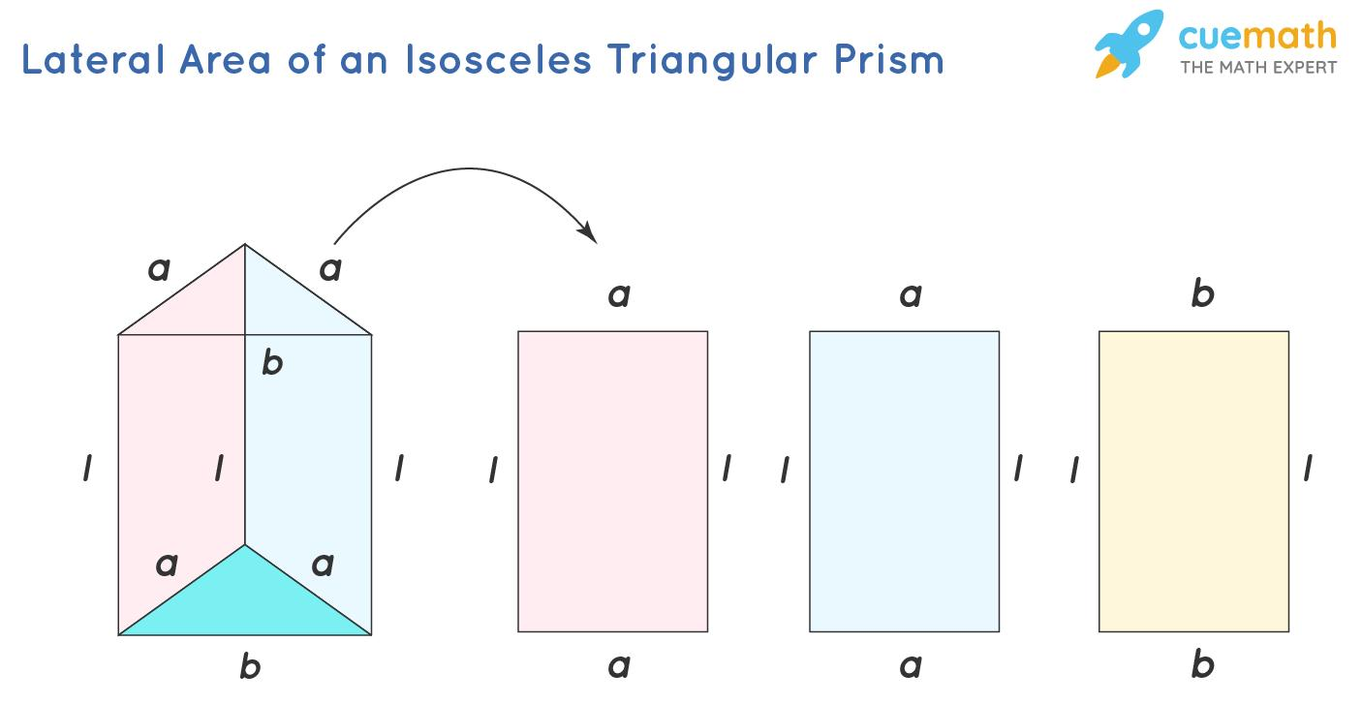
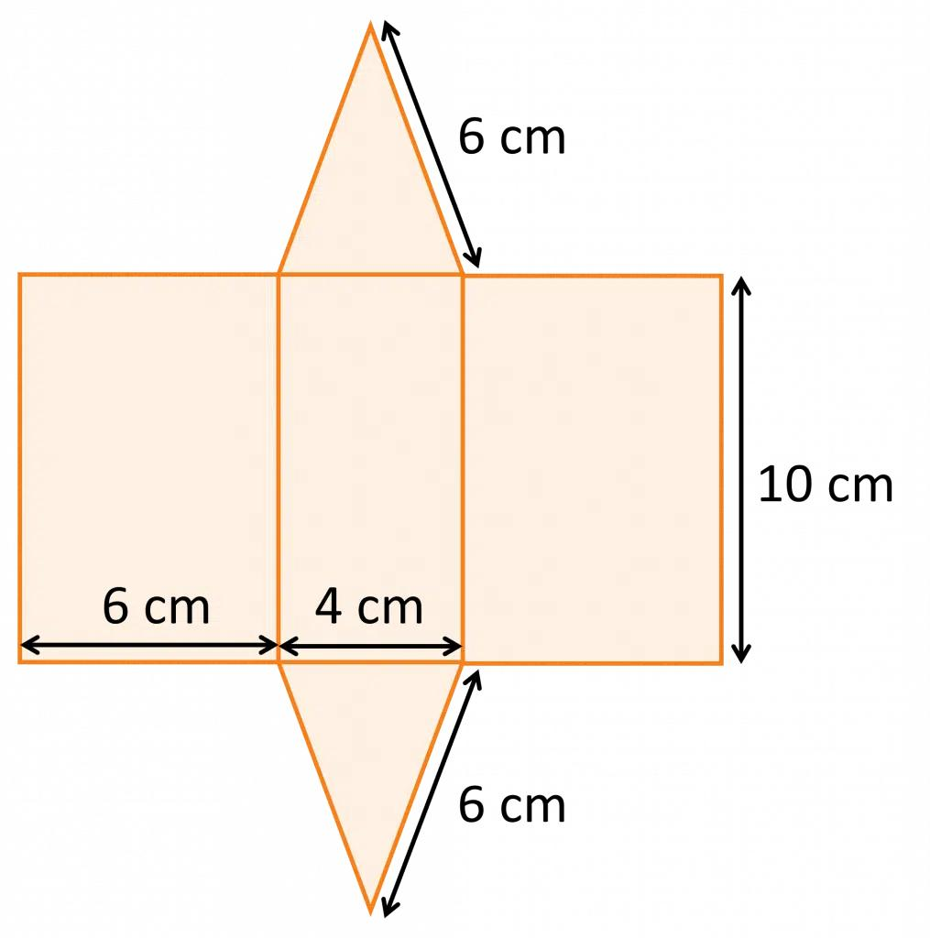
Example
Suppose a prism has a base perimeter of:
$$P=20\text{ cm}$$
and height:
$$h=8\text{ cm}$$
Then:
$$LA=Ph \\ LA=20\left(8\right) \\ \boxed{LA=160{\text{ cm}}^{2}}$$

Lateral Area of a Rectangular Prism
# Source: AI Source: Provided by: [Data Path: Persons Table -> ID Column: 1, Name_En Column: Motasem Essam] -> From: [ChatGPT] on [7/20/2026]
For a rectangular prism with length $l$, width $w$, and height $h$, if the bottom and top are considered the bases:
$$P_{\text{base}}=2\left(l+w\right)$$
Therefore:
$$\boxed{LA=2h\left(l+w\right)}$$
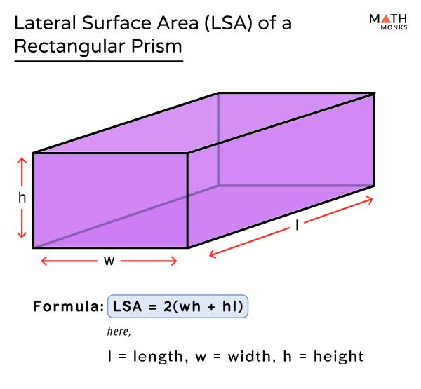
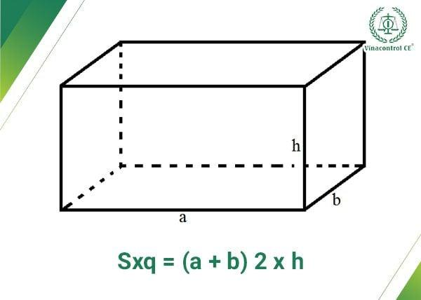
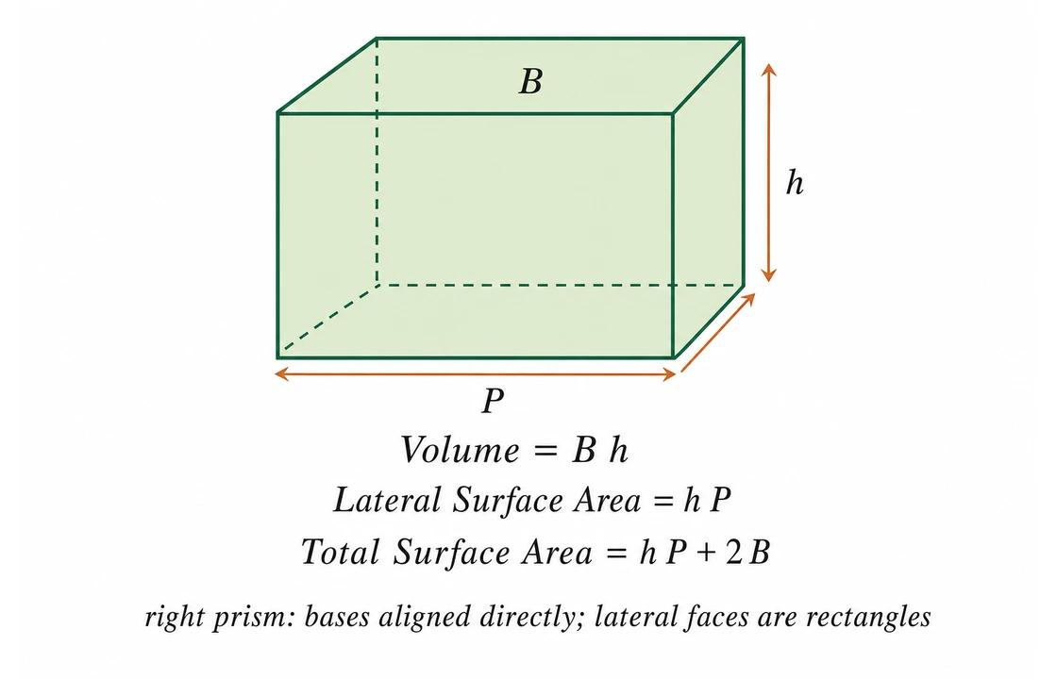
The total surface area is:
$$SA=2\left(lw+lh+wh\right)$$
while:
$$LA=2lh+2wh$$
The difference is the two bases:
$$SA-LA=2lw$$

Lateral Area of a Cylinder
# Source: AI Source: Provided by: [Data Path: Persons Table -> ID Column: 1, Name_En Column: Motasem Essam] -> From: [ChatGPT] on [7/20/2026]
A cylinder has one curved lateral surface.
Its lateral area is:
$$\boxed{LA=2πrh}$$
where:
- $r$ = radius of the circular base
- $h$ = perpendicular height

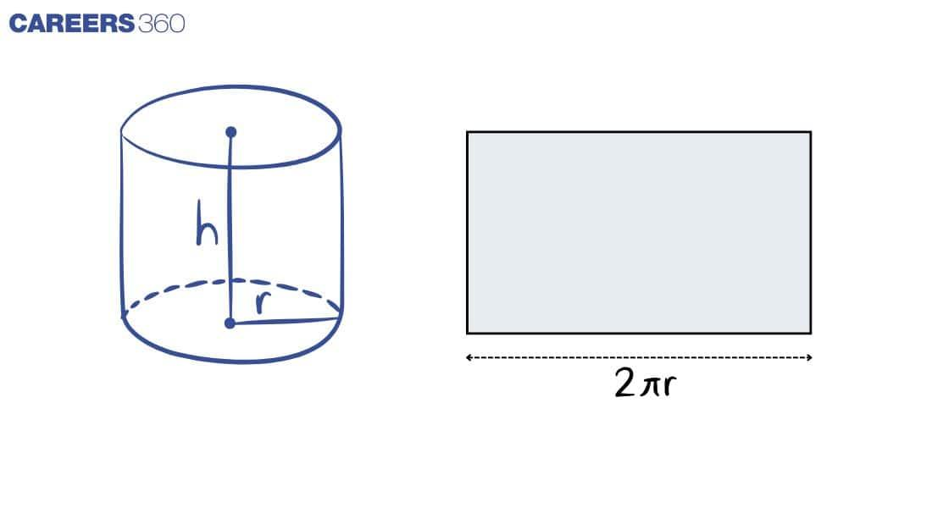
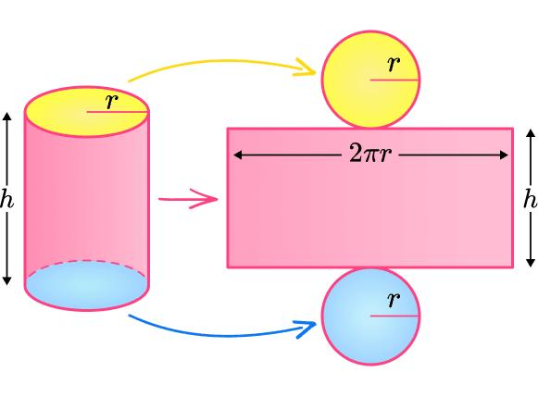
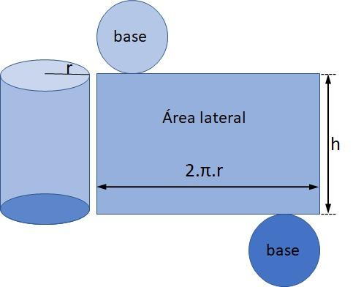
This can be understood by imagining the curved surface being unwrapped into a rectangle:
- Rectangle width = circumference $2πr$
- Rectangle height = $h$
Therefore:
$$LA=\left(2πr\right)h \\ \boxed{LA=2πrh}$$
The total surface area is:
$$SA=2πr^{2}+2πrh$$

Lateral Area of a Pyramid
# Source: AI Source: Provided by: [Data Path: Persons Table -> ID Column: 1, Name_En Column: Motasem Essam] -> From: [ChatGPT] on [7/20/2026]
For a regular pyramid, the lateral surface consists of triangular faces.
The lateral area is:
$$\boxed{LA=\frac{1}{2}Pl}$$
where:
- $P$ = perimeter of the base
- $l$ = slant height
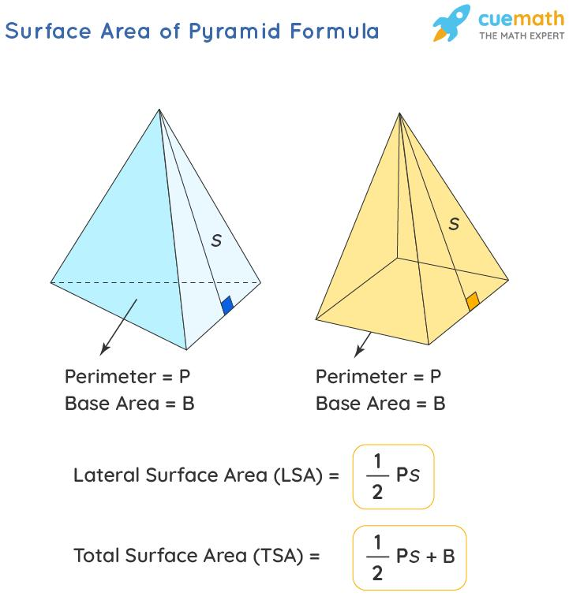
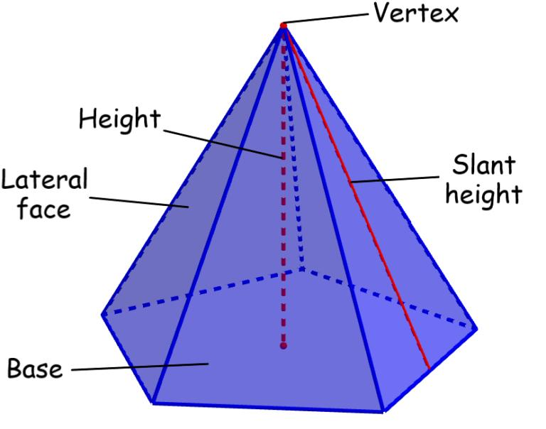

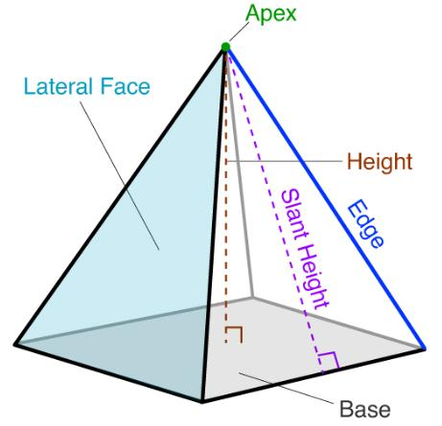
Important
The $l$ in this formula is the slant height, not the perpendicular height of the pyramid.
$$\boxed{\text{Slant Height}≠\text{Perpendicular Height}}$$

Lateral Area of a Cone
# Source: AI Source: Provided by: [Data Path: Persons Table -> ID Column: 1, Name_En Column: Motasem Essam] -> From: [ChatGPT] on [7/20/2026]
A cone has one curved lateral surface.
For a right circular cone:
$$\boxed{LA=πrl}$$
where:
- $r$ = radius of the base
- $l$ = slant height
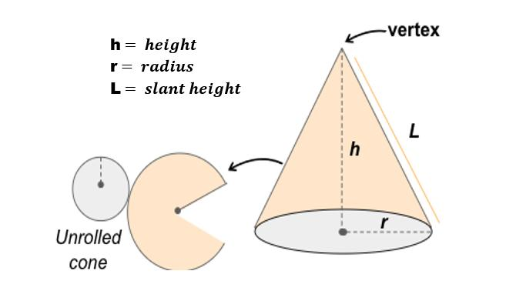
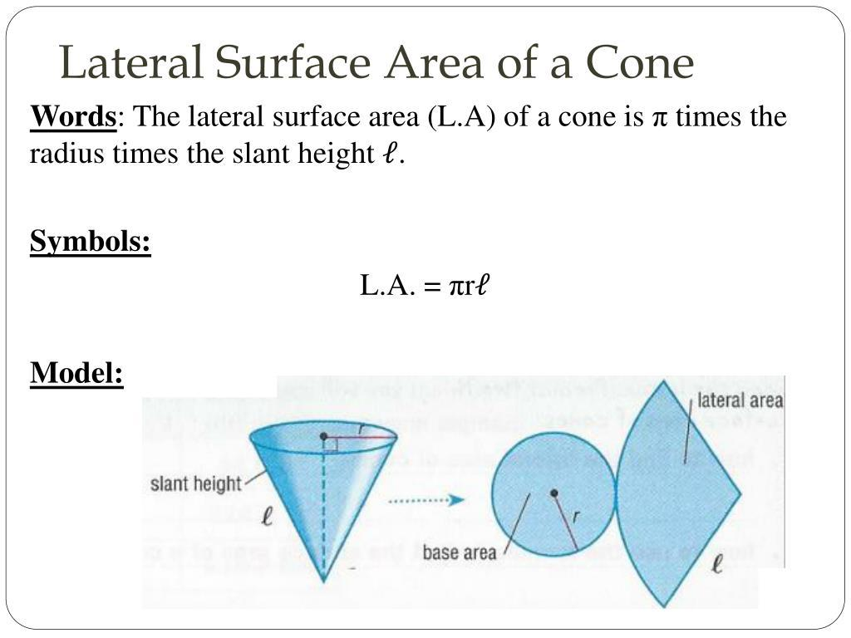
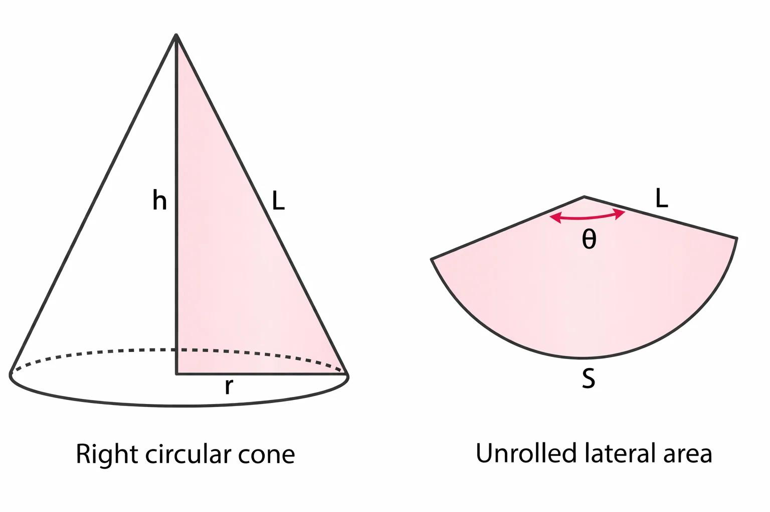
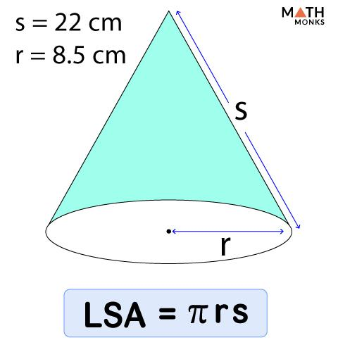
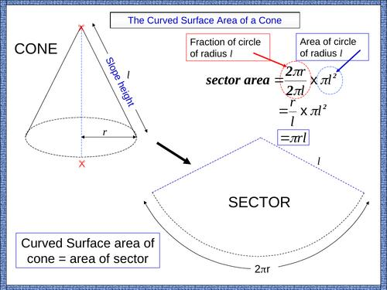
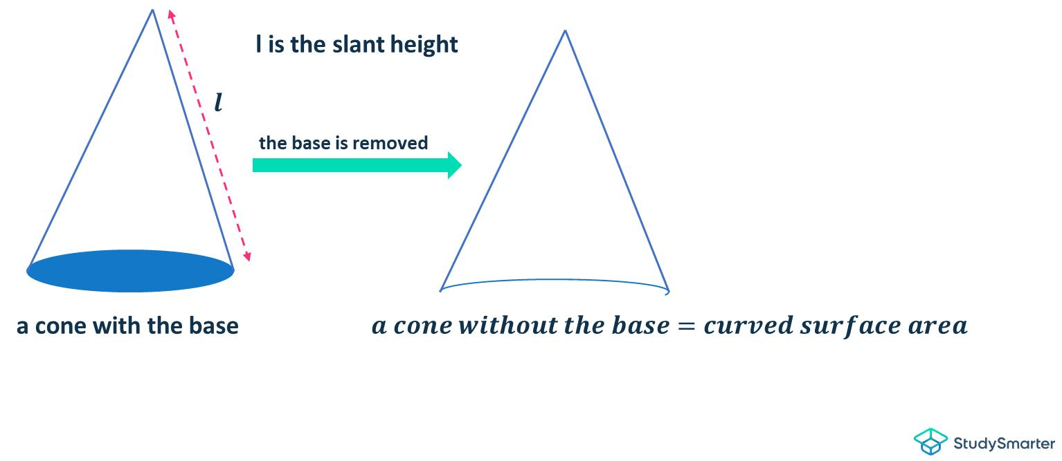
The total surface area is:
$$SA=πr^{2}+πrl$$
Therefore:
$$\boxed{SA=LA+\text{Base Area}}$$

Lateral Area of a Sphere
# Source: AI Source: Provided by: [Data Path: Persons Table -> ID Column: 1, Name_En Column: Motasem Essam] -> From: [ChatGPT] on [7/20/2026]
A sphere does not normally have a lateral area because it has no distinct base and side surfaces.
For a sphere, we normally refer to its surface area:
$$\boxed{SA=4πr^{2}}$$
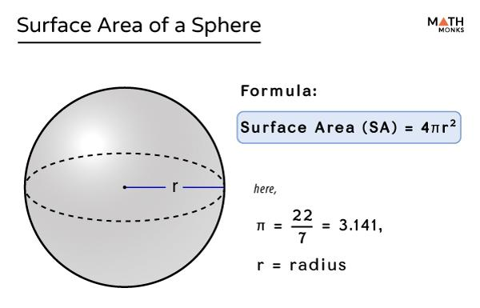
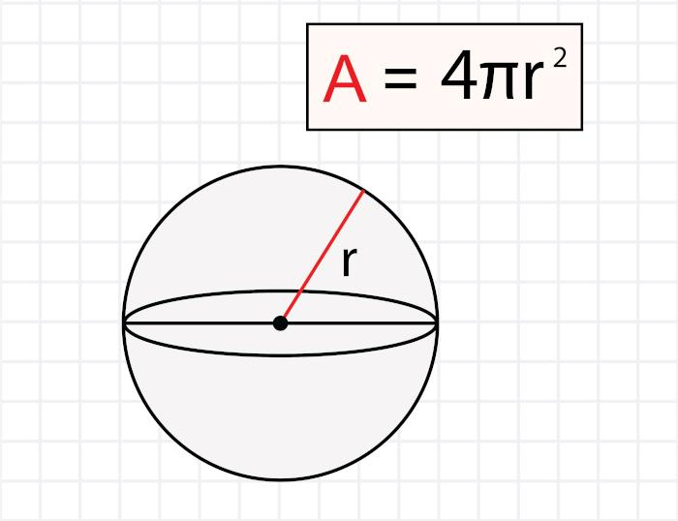
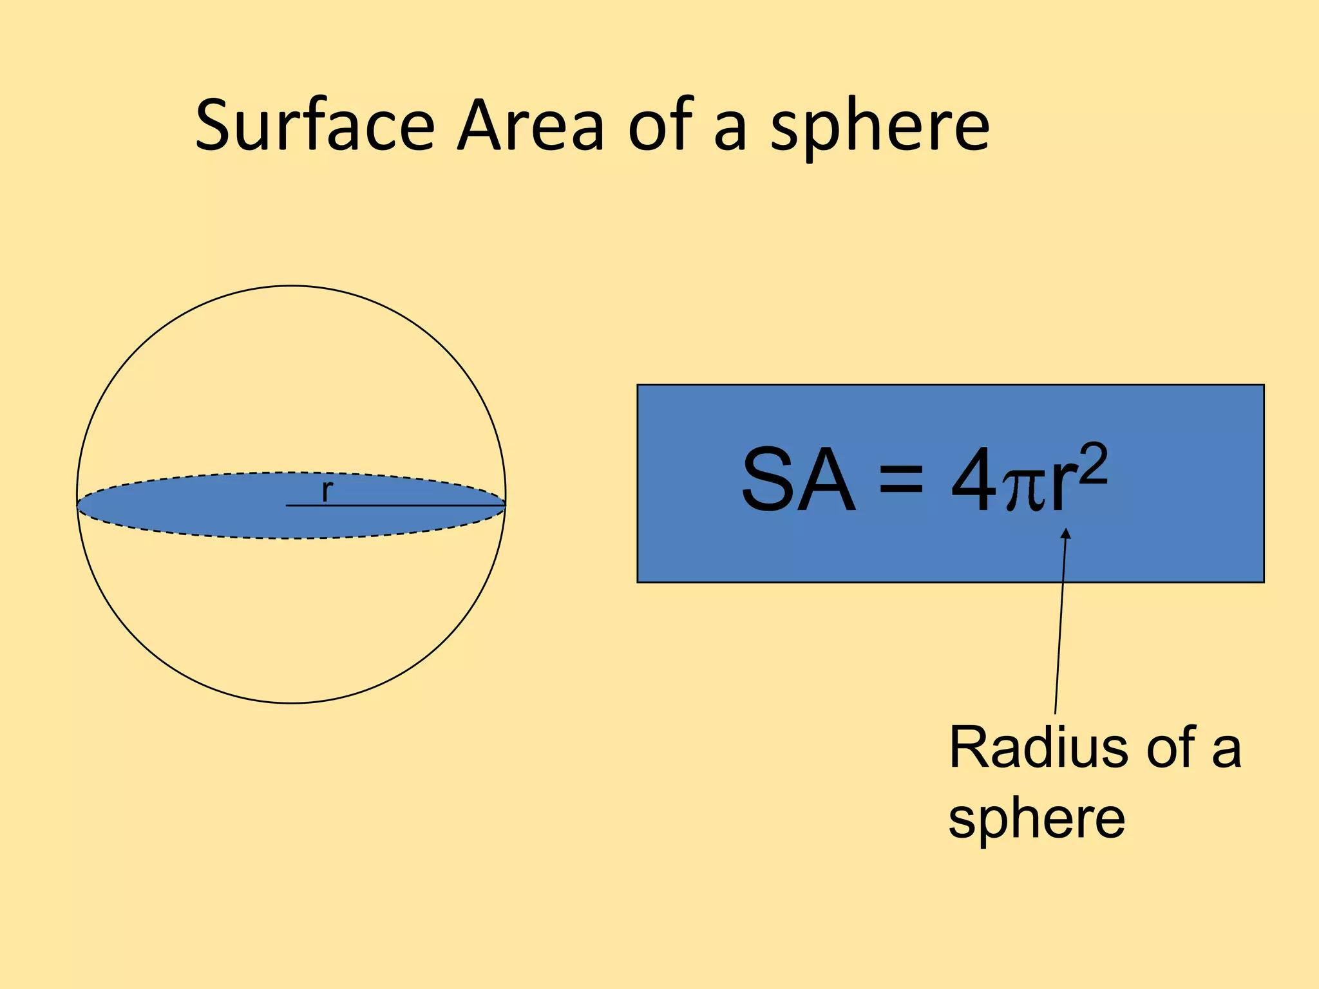
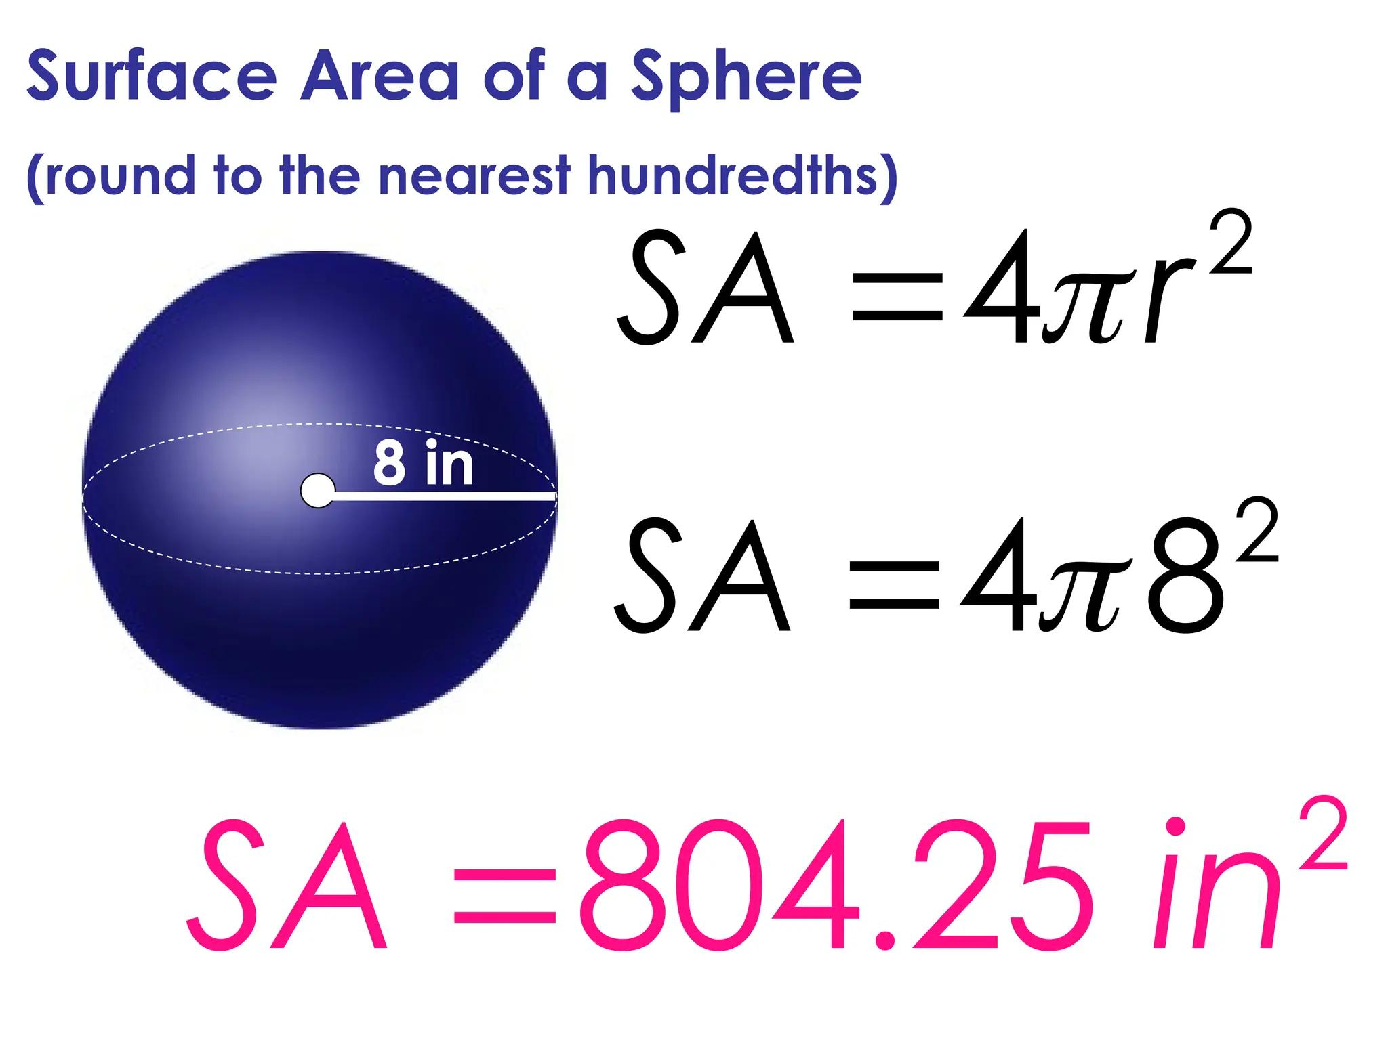
Thus:
$$\boxed{\text{Sphere: Surface Area, not Lateral Area}}$$

Lateral Area and Nets
# Source: AI Source: Provided by: [Data Path: Persons Table -> ID Column: 1, Name_En Column: Motasem Essam] -> From: [ChatGPT] on [7/20/2026]
A geometric net can make lateral area particularly easy to understand.
When a solid is unfolded:
- The base or bases appear as separate base shapes.
- The remaining faces form the lateral surfaces.
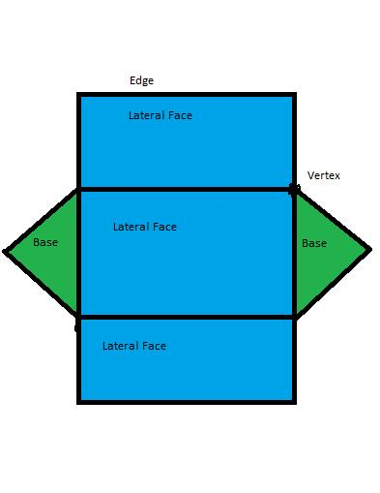
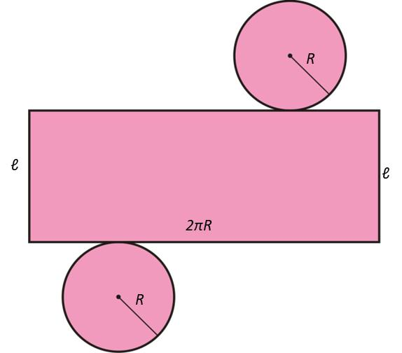
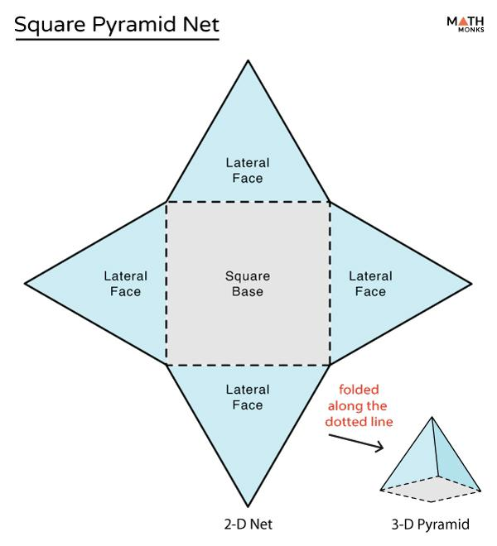
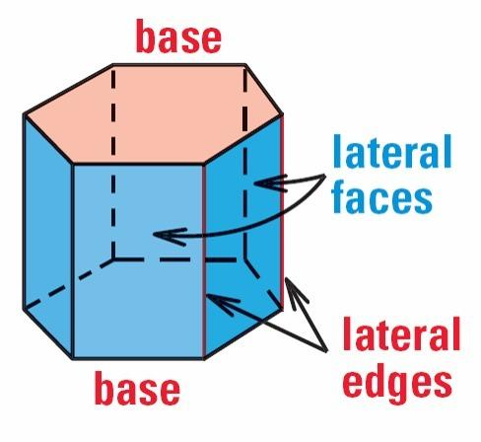
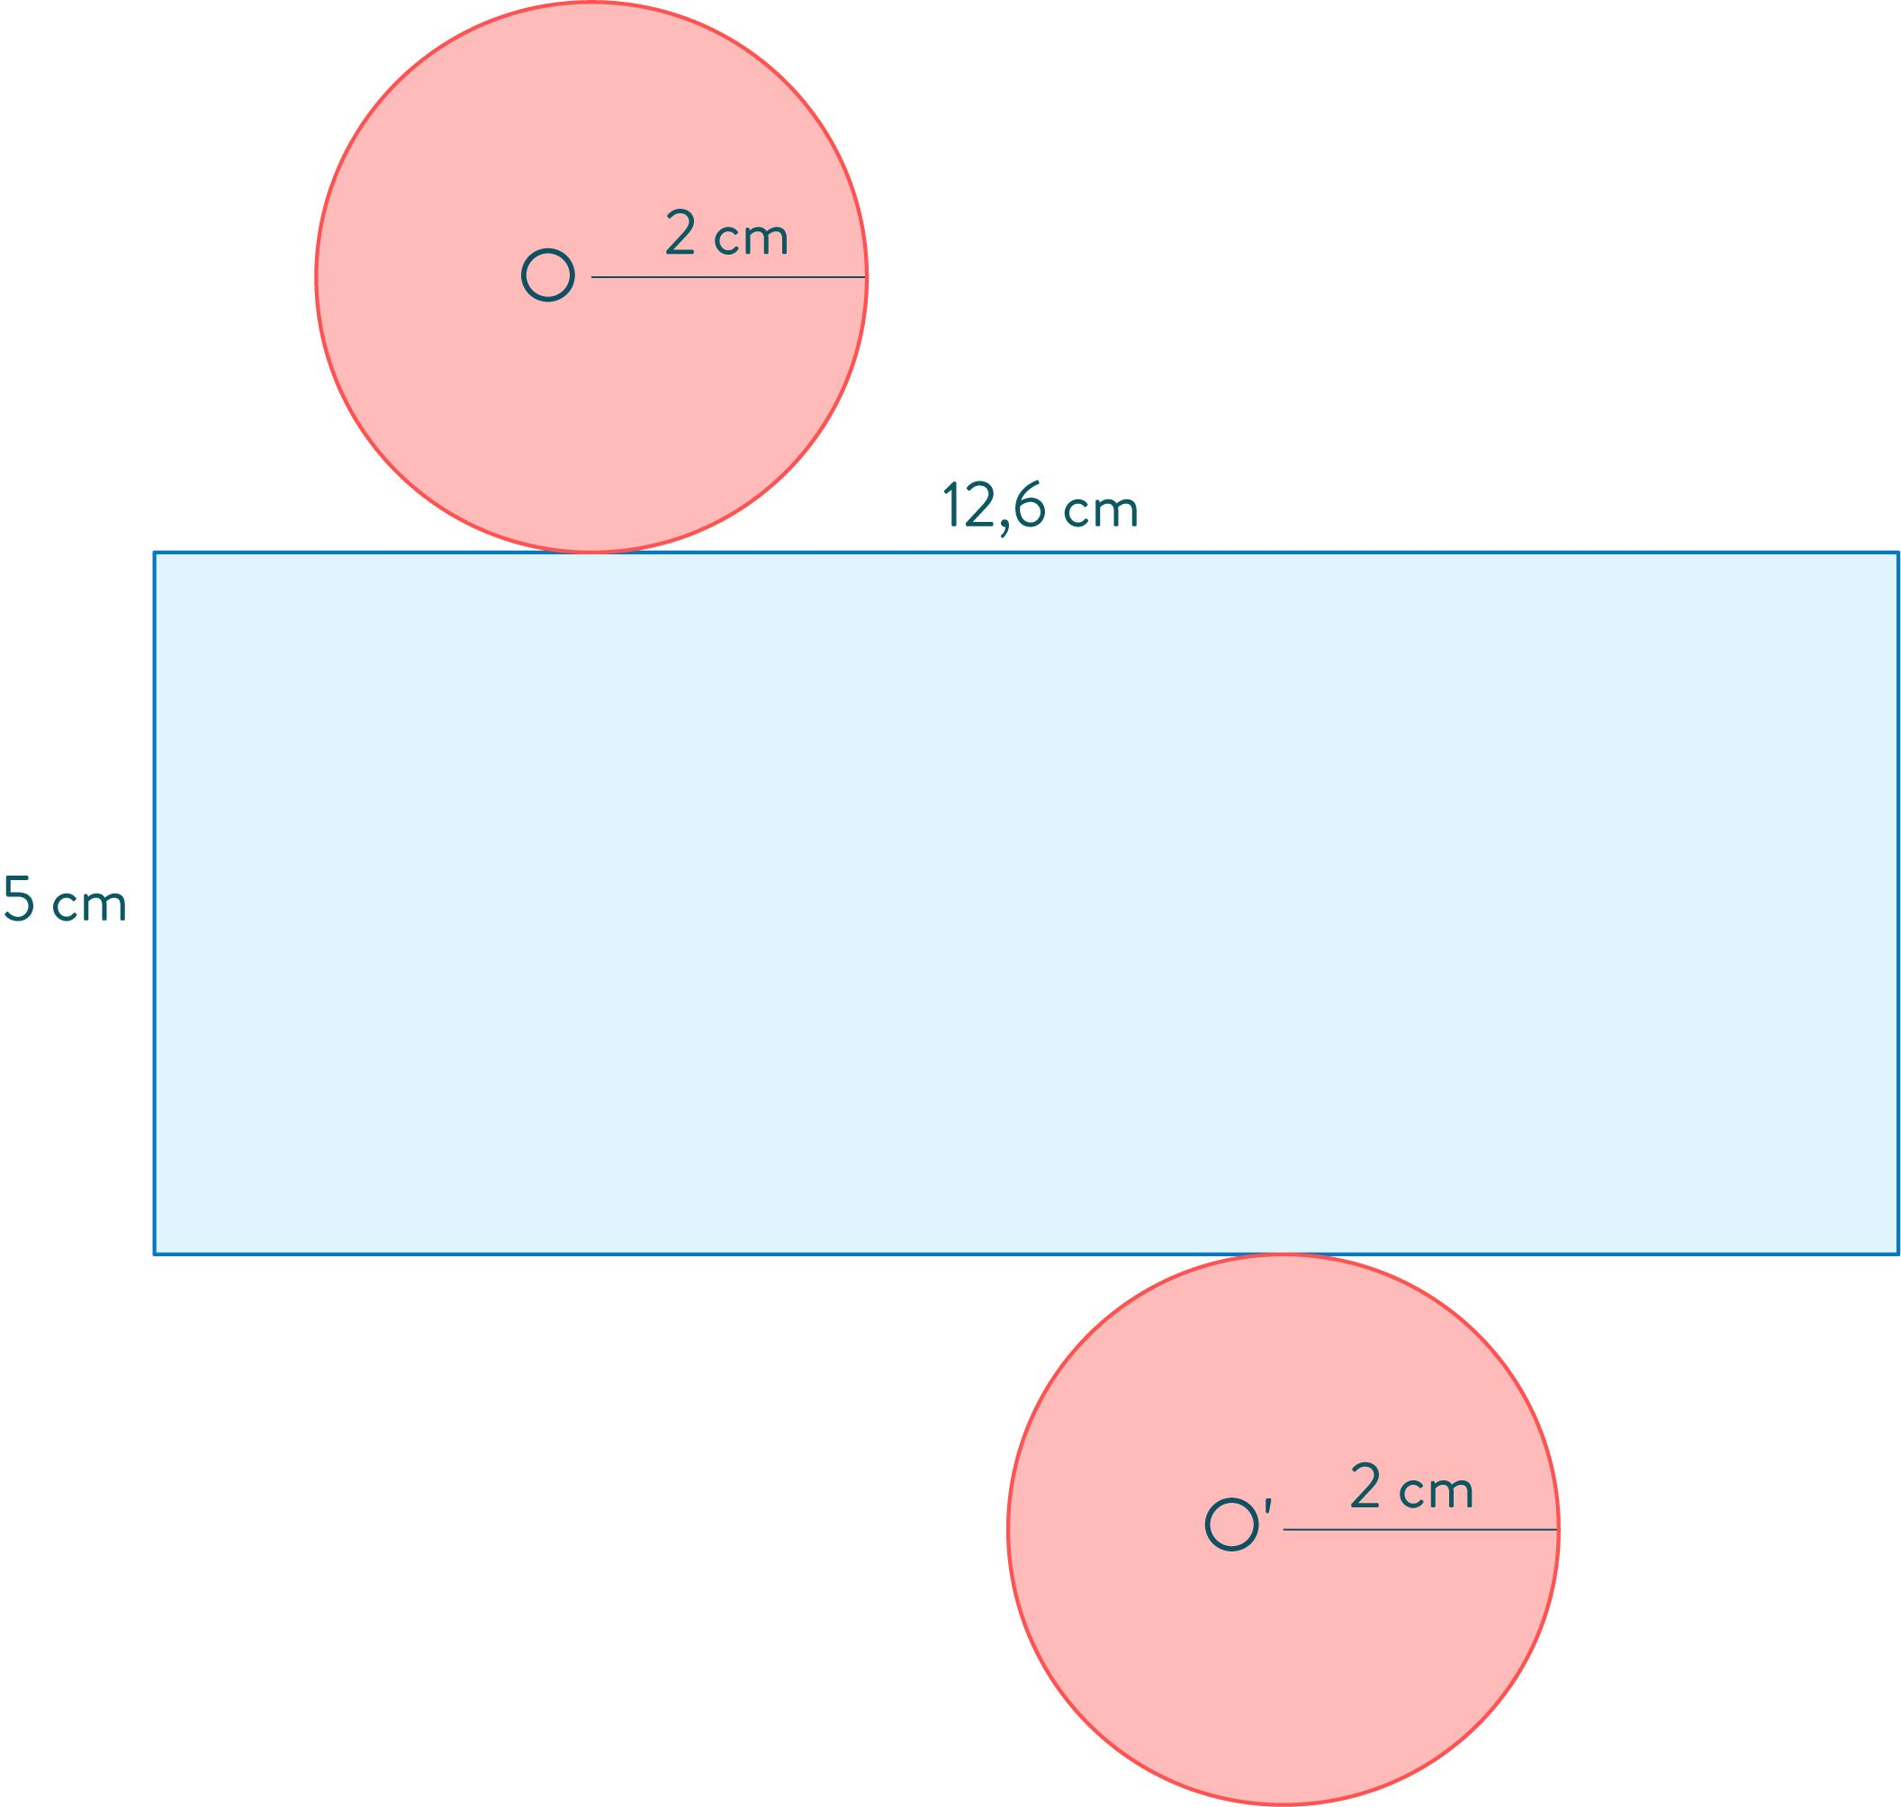
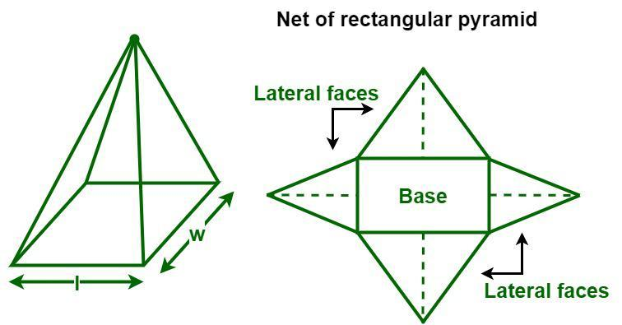
The sum of the lateral faces gives:
$$\boxed{LA}$$

Lateral Area vs. Base Area
# Source: AI Source: Provided by: [Data Path: Persons Table -> ID Column: 1, Name_En Column: Motasem Essam] -> From: [ChatGPT] on [7/20/2026]
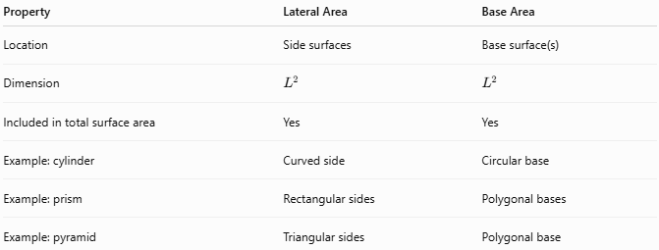
Property | Lateral Area | Base Area
Location | Side surfaces | Base surface(s)
Dimension | $$L^{2}$$ | $$L^{2}$$
Included in total surface area | Yes | Yes
Example: cylinder | Curved side | Circular base
Example: prism | Rectangular sides | Polygonal bases
Example: pyramid | Triangular sides | Polygonal base

Lateral Area vs. Volume
# Source: AI Source: Provided by: [Data Path: Persons Table -> ID Column: 1, Name_En Column: Motasem Essam] -> From: [ChatGPT] on [7/20/2026]
These measure completely different quantities.
Lateral Area
$$\boxed{LA∼L^{2}}$$
Measured in square units.
Volume
$$\boxed{V∼L^{3}}$$
Measured in cubic units.
For a cylinder:
$$LA=2πrh$$
while:
$$V=πr^{2}h$$
Therefore:
$$\boxed{\text{Lateral Area}≠\text{Volume}}$$

Lateral Area and Scaling
# Source: AI Source: Provided by: [Data Path: Persons Table -> ID Column: 1, Name_En Column: Motasem Essam] -> From: [ChatGPT] on [7/20/2026]
If all linear dimensions of a solid are multiplied by a scale factor $k$, its lateral area is multiplied by:
$$\boxed{k^{2}}$$
For example, if a solid is enlarged by a factor of $2$:
$$LA_{\text{new}}=2^{2}LA_{\text{old}} \\ \boxed{LA_{\text{new}}=4LA_{\text{old}}}$$
This is because lateral area is a two-dimensional measurement.

Applications
# Source: AI Source: Provided by: [Data Path: Persons Table -> ID Column: 1, Name_En Column: Motasem Essam] -> From: [ChatGPT] on [7/20/2026]
Lateral area is important in:
- Geometry
- Measurement Theory
- Engineering
- Architecture
- Construction
- Manufacturing
- Mechanical Design
- Technical Drawing
- CAD (Computer-Aided Design)
- 3D Modeling
- Packaging Design
- Structural Design

Advantages
# Source: AI Source: Provided by: [Data Path: Persons Table -> ID Column: 1, Name_En Column: Motasem Essam] -> From: [ChatGPT] on [7/20/2026]
Understanding lateral area helps to:
- Measure the total area of the side surfaces of a 3D solid.
- Calculate the amount of material needed to cover the sides of an object.
- Calculate the surface area of prisms, cylinders, pyramids, and cones.
- Support construction and manufacturing calculations.
- Determine coating, painting, wrapping, or covering requirements.
- Support accurate engineering and architectural designs.
- Simplify surface-area calculations by separating the bases from the side surfaces.
- Analyze the relationship between the dimensions of a solid and its surface coverage.

Limitations
# Source: AI Source: Provided by: [Data Path: Persons Table -> ID Column: 1, Name_En Column: Motasem Essam] -> From: [ChatGPT] on [7/20/2026]
Lateral area:
- Applies primarily to three-dimensional solids.
- Excludes the base or bases.
- Is a two-dimensional measurement expressed in square units.
- Depends on how the bases and lateral surfaces are defined.
- Is not normally defined separately for a sphere.
- Does not describe the volume of a solid.
- May require slant height rather than perpendicular height for cones and pyramids.

Key Points
# Source: AI Source: Provided by: [Data Path: Persons Table -> ID Column: 1, Name_En Column: Motasem Essam] -> From: [ChatGPT] on [7/20/2026]
$$\boxed{\text{Lateral Area}=\text{Total Area of the Side Surfaces}}$$
Lateral area:
- Is primarily a 3D geometric measurement.
- Includes the side surfaces.
- Excludes the base or bases.
- Is measured in square units.
- Is part of total surface area.
- For prisms, commonly uses $LA=Ph$.
- For cylinders, $LA=2πrh$.
- For regular pyramids, $LA=\frac{1}{2}Pl$.
- For cones, $LA=πrl$.
- Is not normally defined separately for spheres.

Conclusion
# Source: AI Source: Provided by: [Data Path: Persons Table -> ID Column: 1, Name_En Column: Motasem Essam] -> From: [ChatGPT] on [7/20/2026]
Lateral area is the total area of the side surfaces of a three-dimensional solid, excluding its base or bases. It provides a way to separate the side surfaces from the complete external surface of a solid. For prisms and cylinders, lateral area is especially useful because the side surfaces can be treated systematically using the base perimeter and height. For pyramids and cones, the slant height is used in the lateral-area formula. Thus:
$$\boxed{\text{Total Surface Area}=\text{Lateral Area}+\text{Base Area(s)}}$$

